
Business Question and Visualization Report

Date | 24 September 2024
Team ID | PNT2022TMIDxxxxxx
Project Name | Electric Vehicle Market Performance & Insights
Maximum Marks | 5 Marks

Visualization development refers to the process of creating graphical representations of data to facilitate understanding, analysis, and decision-making. The goal is to transform complex datasets into visual formats that are easy to interpret, enabling users to gain insights and make informed decisions. Visualization development involves selecting appropriate visual elements, designing layouts, and using interactive features to enhance the user experience. This process is commonly associated with data visualization tools and platforms, and it plays a crucial role in business intelligence, analytics, and reporting
Business Questions and Visualisation
The process involves defining specific business questions to guide the creation of meaningful and actionable visualizations in Tableau. Well-framed questions help in identifying key metrics, selecting relevant data, and building visualisation that provide insights.

Business Questions and Visualisation
1. Which EV manufacturers have the highest sales?
- Visualization: Bar chart showing sales by manufacturer.
- Screenshot of visualisation
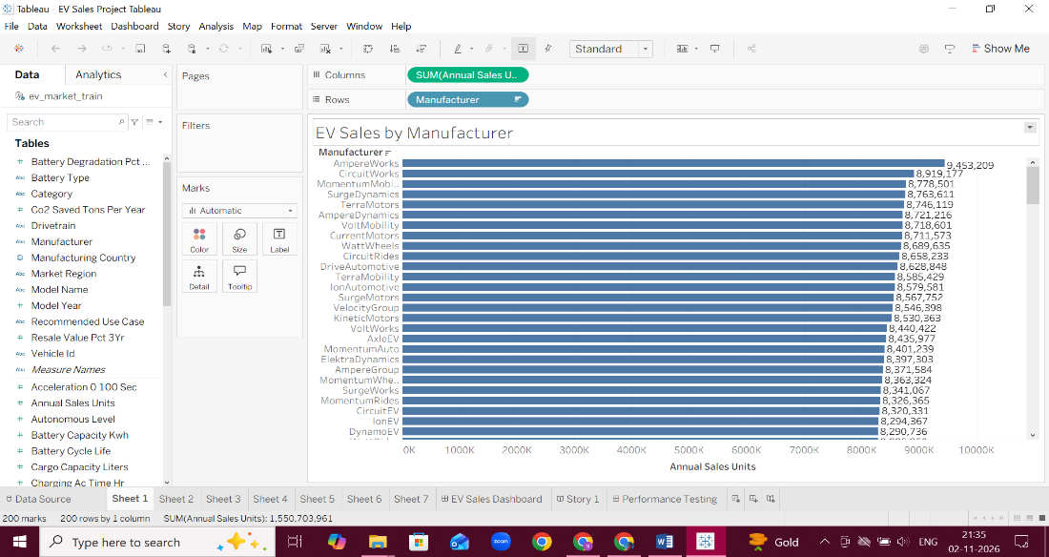
2. Which EV vehicle category contributes the most to total sales?
- Visualization: Donut chart showing EV sales by category.
- Screenshot of visualisation
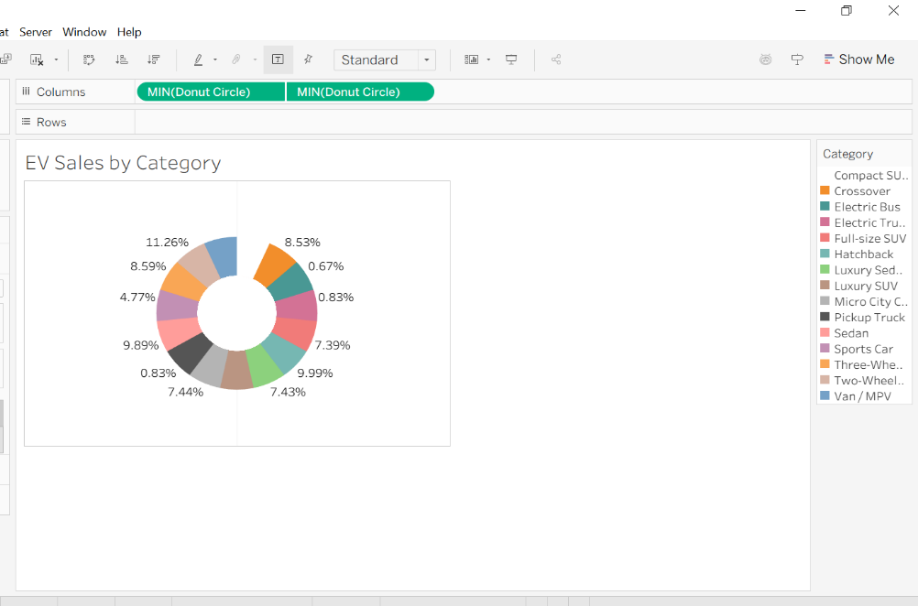
3. How have EV sales changed over the years?
- Visualization: Line chart showing yearly EV sales trends.
- Screenshot of visualisation
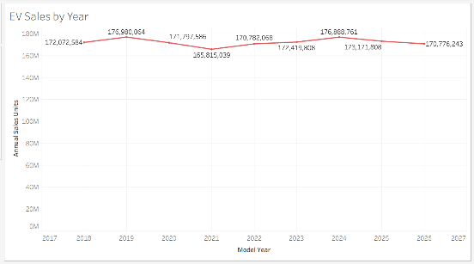
4. Which battery technology has the highest annual EV sales?
- Visualization: Bar chart comparing annual sales by battery technology.
- Screenshot of visualisation
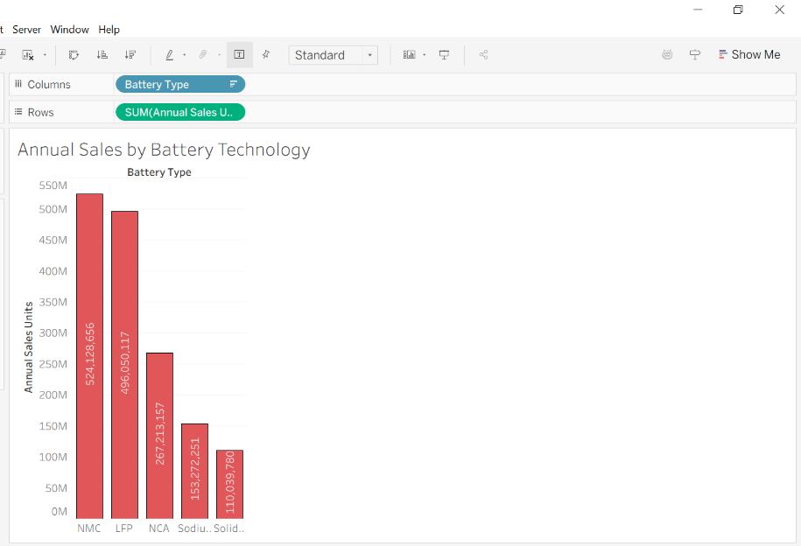
5. Which countries have the highest EV manufacturing presence?
- Visualization: Map visualization showing the geographical distribution of EV manufacturing by country.
- Screenshot of visualisation
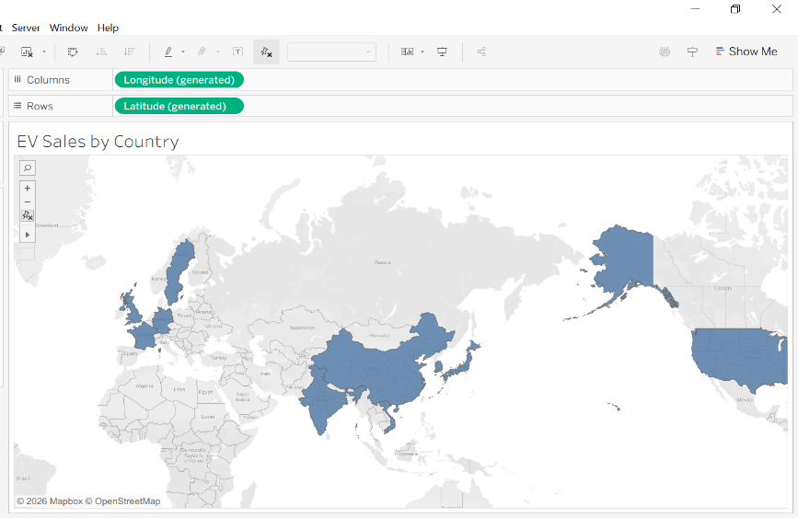
6. What is the relationship between EV price and annual sales?
- Visualization: Scatter plot showing the relationship between EV prices (USD) and annual sales units.
- Screenshot of visualisation: Price vs Annual Sales.
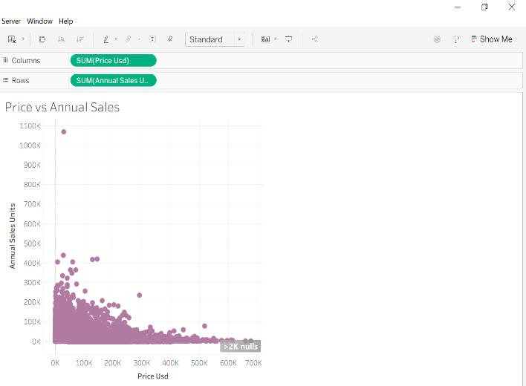
7. How are EV sales distributed among different manufacturers?
- Visualization: Treemap showing EV sales by manufacturer.
- Screenshot of visualisation: Sales by Manufacturer (Treemap).


